The Human Rights Innovation Fund

and Indigenous Youth Justice campaign

The Report – A Brighter Tomorrow …

In June 2015, Amnesty International Australia launched the report “A Brighter Tomorrow: Keeping Indigenous kids in the community and out of detention in Australia”. Indigenous youth detention in Australia is a national crisis – Indigenous young people are 26 more times more likely to be in detention than non-Indigenous young people. Western Australia detains Indigenous children at 53 times the rate of their non-Indigenous peers.
You can read the report, “A Brighter Tomorrow …” here:
http://www.amnesty.org.au/images/uploads/aus/A_brighter_future_National_report.pdf

Amnesty will be working over the coming years to ensure a brighter tomorrow for Indigenous kids. The report makes comprehensive, practical recommendations to government on how to reduce the rate of Indigenous youth incarceration and make communities safer. It also examines the innovative Indigenous-led prevention and diversion programs that are achieving impressive results.

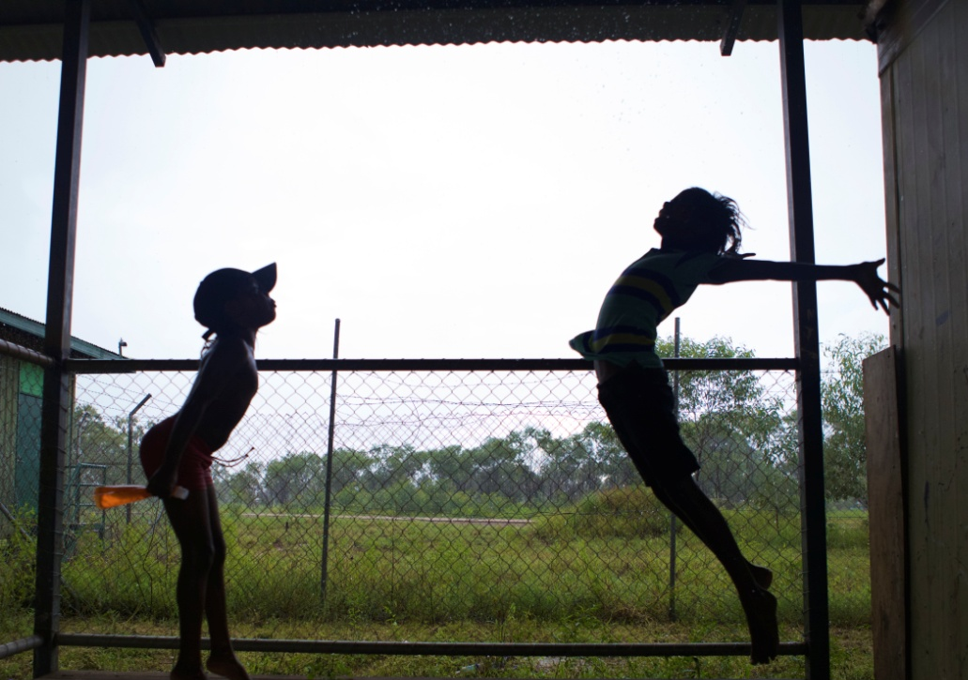

The Campaign – Community is Everything

Amnesty’s Indigenous Youth Justice campaign, Community is Everything, is designed to end the overrepresentation of Indigenous young people in detention within a generation.

The Human Rights Innovation Fund

Between 2015 and 2019, in recognition of the importance of this campaign, Amnesty International Australia will provide at least one grant each year, through the Human Rights Innovation Fund, to Indigenous organisations working to:

- end youth incarceration; and/or

- to support Indigenous individuals/families/communities experiencing youth detention.

Your proposal could involve remote or urban communities, it could complement or be an element of an early intervention, prevention or diversionary program, or it could be an event or activity that supports the campaign. Amnesty encourages Indigenous ‘stakeholders’ to develop creative interesting, positive initiatives that will help keep kids out of detention and in the community where they belong.

Who can apply?

The Human Rights Innovation Fund for Indigenous Youth Justice initiatives is open to Indigenous-led and directed organisations only.

Funding Criteria

- Projects must have a demonstrable human rights impact in that it supports the aim of Amnesty’s Indigenous Youth Justice campaign;

- Projects must be an Indigenous-led and designed initiative;

- Projects must be achievable within the funding available (maximum $8,000);

- Smaller projects, even very small, are very welcome;

- Projects must be completed within one year of the project’s start date;

- Amnesty International Australia cannot pay wages. If wages form part of your project budget, you will need to be an employer or the person(s) to be paid will need to have an ABN;

- Successful applicants will be required to submit a short project report/evaluation within two months of the completion of the project.

How do I apply?

There are four quarterly grant rounds each year. The attached application form must be sent to hrif@amnesty.org.au by the 28th February 2018. We are in the midst of reviewing the dates for the rest of the year so stay tuned for more information.

How are applications assessed?

Proposal will be assessed by the Human Rights Innovation Fund Committee (comprising staff and active Amnesty International supporters) and applicants will be contacted within 8 weeks of the funding round closing.

More information?

If you would like to discuss your ideas, please contact us at hrif@amnesty.org.au.

HUMAN RIGHTS INNOVATION FUND APPLICATION FORM
INDIGENOUS YOUTH JUSTICE
CONTACT DETAILS
Contact person: |  |  | Email address:
Organisation Name |  |  | Phone numbers:
ABN
Address
Tell us a bit about your organisation:
PROJECT DESCRIPTION
Name of proposed project:
Description of the project:
Maximum one page
What human rights impact will your project achieve:

How will you know your project has been successful?

Who will be involved in your project?

Will the project be in conjunction with another group or organisation? If so which who?

Please attach letter(s) indicating ‘in principle’ support for the project

Please provide the name and contact details of two referees if possible.

When would your project start and end?

PROJECT BUDGET
Amount Requested (Maximum $8,000) |  | $

PLEASE NOTE: Amnesty International Australia cannot pay wages. If wages form part of your project budget, you will need to be an employer or the person(s) to be paid will need to have an ABN.
COSTS  Please provide a breakdown of project costs |  |  | $ AMOUNT

INCOME

Please provide detail of any income that will offset these costs

DECLARATION BY PROPOSER

The information in this application is true and reasonable to the best of my knowledge. I understand that this is an application only and may not result in funding.
Signed: |  | Date:

Print Name:

Please submit your completed application and any attachment by email to hrif@amnesty.org.au by:
28th February

