[Date]  [Addressee]  [Title]  [Address] |  | AMNESTY INTERNATIONAL AUSTRALIA ABN 64 002 806 233  Street address: Postal address:  79 Myrtle Street Locked bag 23  Chippendale Broadway  NSW 2008 NSW 2007  T: (02) 83967618 F: (02) 83967677  E: exec.admin@amnesty.org.au W: www.amnesty.org.au
Dear [Addressee]

RE: XX

Copy

For further information, or to discuss and organise a meeting, please contact XX at XX or XX.
Yours sincerely,
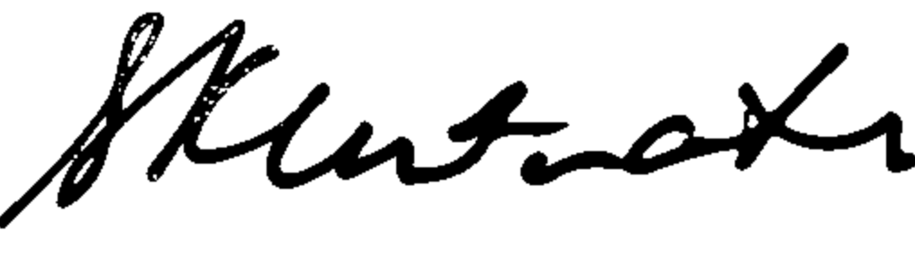
Sam Klintworth
National Director
Amnesty International Australia

